Name:______________________________________

Writing Book
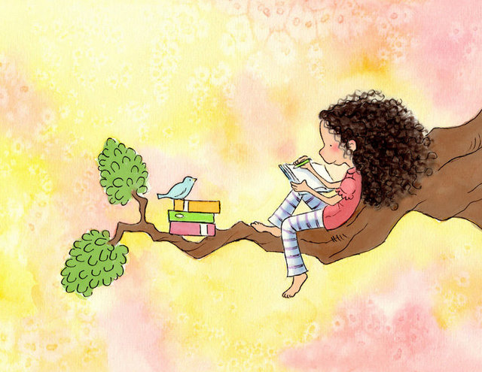

Dear Parents,

Students can write each story over two days.
On each page is an image that the students will write about. BEFORE they begin writing they need to talk to you about:

WHO is in the picture?
WHAT is happening?
WHERE is it/are they?
WHEN is it? (avoid using numbers – use descriptive language – for example; “before breakfast” or “as the sun went down”
WHY? Explain the events they have described.
They can then begin to write their story.
Year 1’s need to be writing three or more compound sentences for EACH of the above prompts.
Year 2’s need to be writing six or more compound sentences for EACH of the above prompts
Please ask your child to use the checklist on the bottom of each page to check their writing.

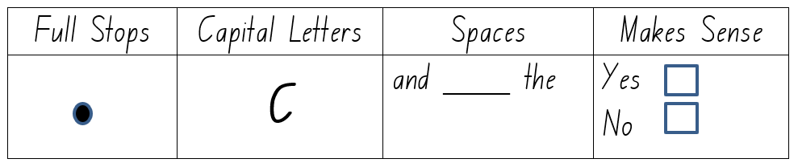

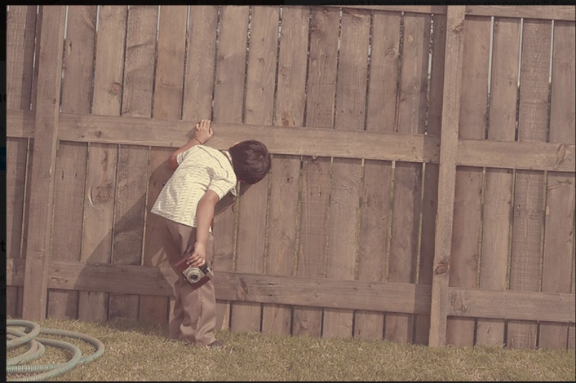
The hole in the Fence
Date:__________________
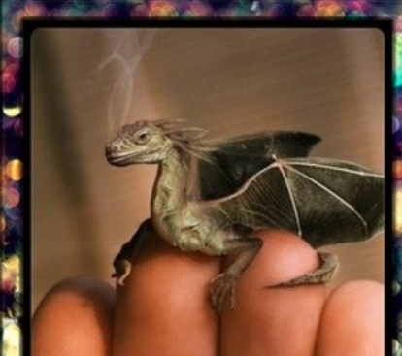
The Tiny Dragon
Date:__________________
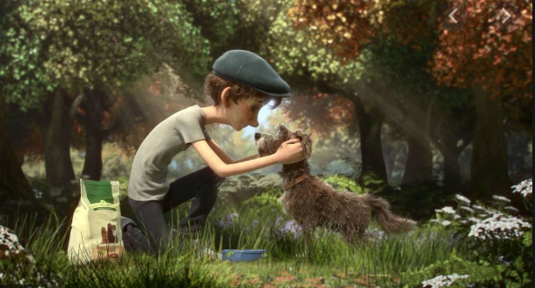
Title_________________________________________________
Date:__________________

The Tiny Dragon
Date:__________________

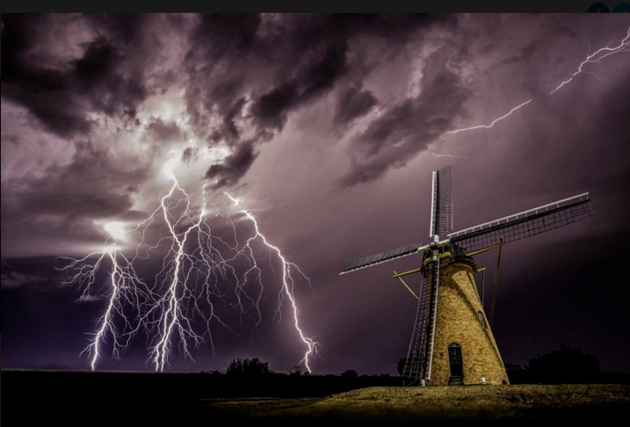
Date:__________________

Title_________________________________________________

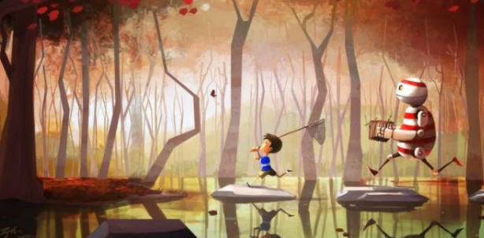
Date:__________________
Title_________________________________________________

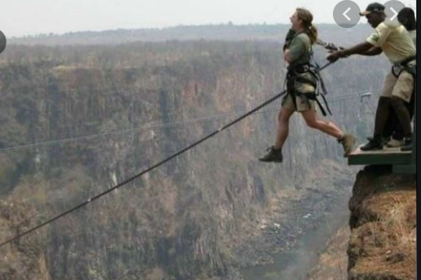
Title_________________________________________________
Date:__________________

Title_________________________________________________
Date:__________________

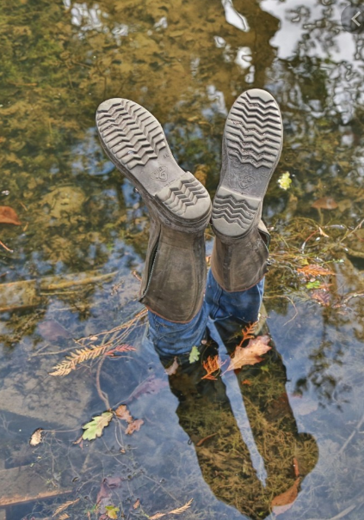
Date:__________________
Title_________________________________________________

